Indian Institute of Technology, Kharagpur

Centre for Educational Technology

**Mid Semester Examination 2017**

Subject**: INTRODUCTION TO DIGITAL SPEECH PROCESSING** Code: ET60007

**Time: 2:00 Hours** PART-A:-10*2=20; PART-B:-5*6=30 **Full Marks =50**

***Answer all the questions of PART-A and PART-B***

*(Please enclose the Annexure-1 along with the answer script)*

**PART-A**

1. The frequency response of a uniform tube is as given in the following equation (1). The length of the tube l=17.5 cm and speed of sound c=350m/s. Draw the volume velocity vs. Frequency curve for first 4 roots?



2. Draw the directivity pattern of an omni-directional microphone

3. What are the perceptual parameters of speech?

4. An audio signal is recorded using the following format.

FS = 8 kHz, encoded with16 bit and recorded in MONO

To store 3s signal in PCM WAV format how much memory is required?

5. Which of the following is true for narrow band spectra?

(I) Time resolution low, frequency resolution high

(II) Time resolution high, frequency resolution low

(III) None of the above.

6. Draw the glottal flow wave from and define the following

Open phase, b) Closed phase and c) Period

7. What will be value of perceive pitch (in Mel Scale) for the 180 Hz tone.



8. What are the perceptual parameters of speech?

9. Second formant frequency of a steady state vowel is F1=1200Hz. Consider that the vowel is produced using a single lossless acoustic tube. What will be the length of the vocal tract? Where the speed of sound c=350m/s.

10. Two source of speech signal producing a vowel /o/. The formant frequencies of the sources are differing by 3-4%. If a human being perceives the two sounds as same sound explains why this happen?

**PART-B**

1. (a) Describe the state of the Glottis during the pronunciation of the following phoneme?

(i) /k/, (ii) /b/, (iii) /a/, (iv) /l/, (v) /ʃ/

(b) Draw a schematic diagram of the upper palate and mark the place of articulation of the following phoneme

(i) /m/, (ii) /g/, (iii) /t/, (iv) /h/, (v) /ʃ/

2. Bilabial unvoiced fricative sound is produce by constrictions in vocal tract at lips. Consider the vocal tract is model using a lossless uniform tube of length l. The output sound pressure at lips to produce the above fricative sound is *PL(Ω)ejΩt*. Using the wave equation derive the transfer function *H(Ω)*(where *H(Ω)=UL(Ω)/PL(Ω))*

3. A speech production system is model using Uniform Tube Modeling and it produces a voice sound. Figure -1 shows the spectrum of the above voice sound along with the formant frequency and formant bandwidth with sampling frequency ***FS = 10 kHz***. Derive the transfer function of the above Uniform Tube Model. General equation of the Uniform Tube Model is given in equation (1). Draw the digital implementation diagram of the model.

 (1)

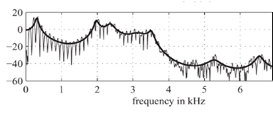

F1=4200 Hz

BW=140 Hz

F1= 5000 Hz

BW=112 Hz

F1=740 Hz

BW=68 Hz

F1=350 Hz

BW=98 Hz

F1=3100 Hz

BW= 55 Hz

F1= 2200 Hz

BW=65 Hz

Figure-1

4. To produce a voiced speech signal of bandwidth ***10 KHz*** how many section of lossless tubes are required. Where length of the tube is ***17.5cm*** and **c=35000cm/s**. Prove that one resonant frequency will be appear in every ***1000Hz***.

5. (a) Figure-2 (a) and (b) in annexure-1 represents waveform and spectrogram of a VCV speech segment where C represent consonant and V represent Vowel. Mark the occlusion period, burst and VOT part. Write the manner of articulation of the consonant represented by the figure-2.

(b) A voiced based speed dialing system of a mobile phone is design for the following word. Figure-3 (I) to (V) in **Annexure-1** shows spectrograms of one version of each of these words. Using your knowledge of acoustic phonetics, determine which spectrogram corresponds to which word.

(I) Home, (II) DIAL, (III) office, (IV) doctor, (V) School, (VI) Disconnect

**Annexure-1**

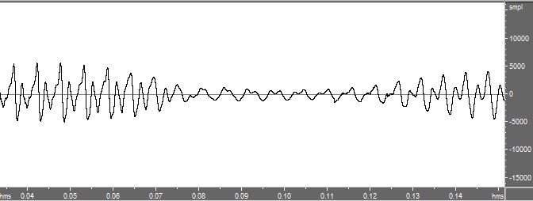

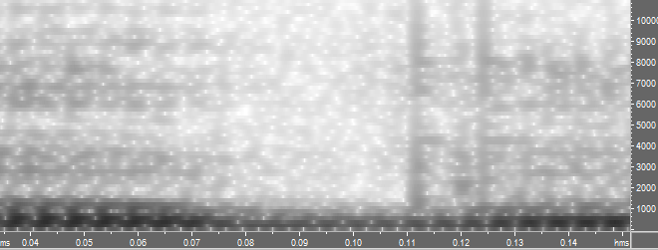

Figure-2

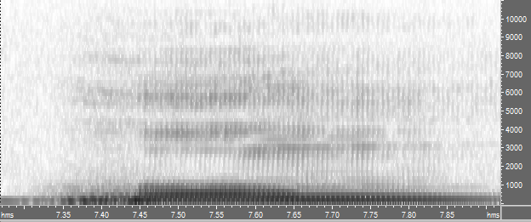 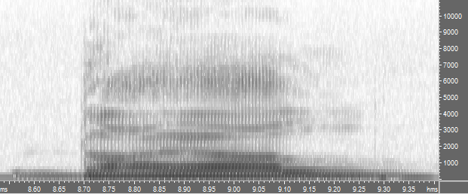

Home Dial

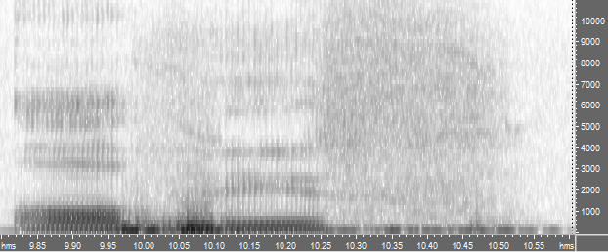 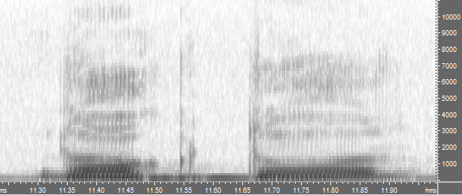

Office doctor

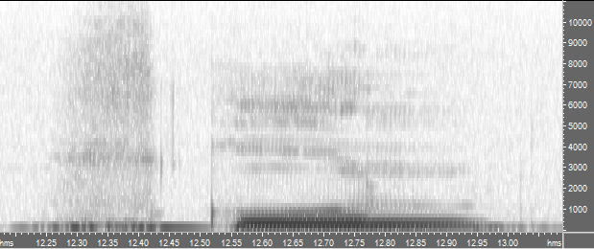 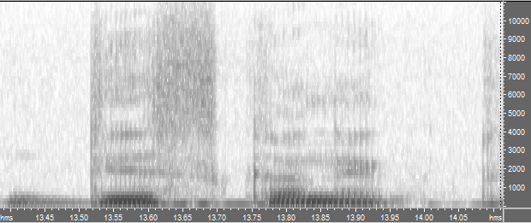

School Disconnect